**Free Trade Agreement (FTA)-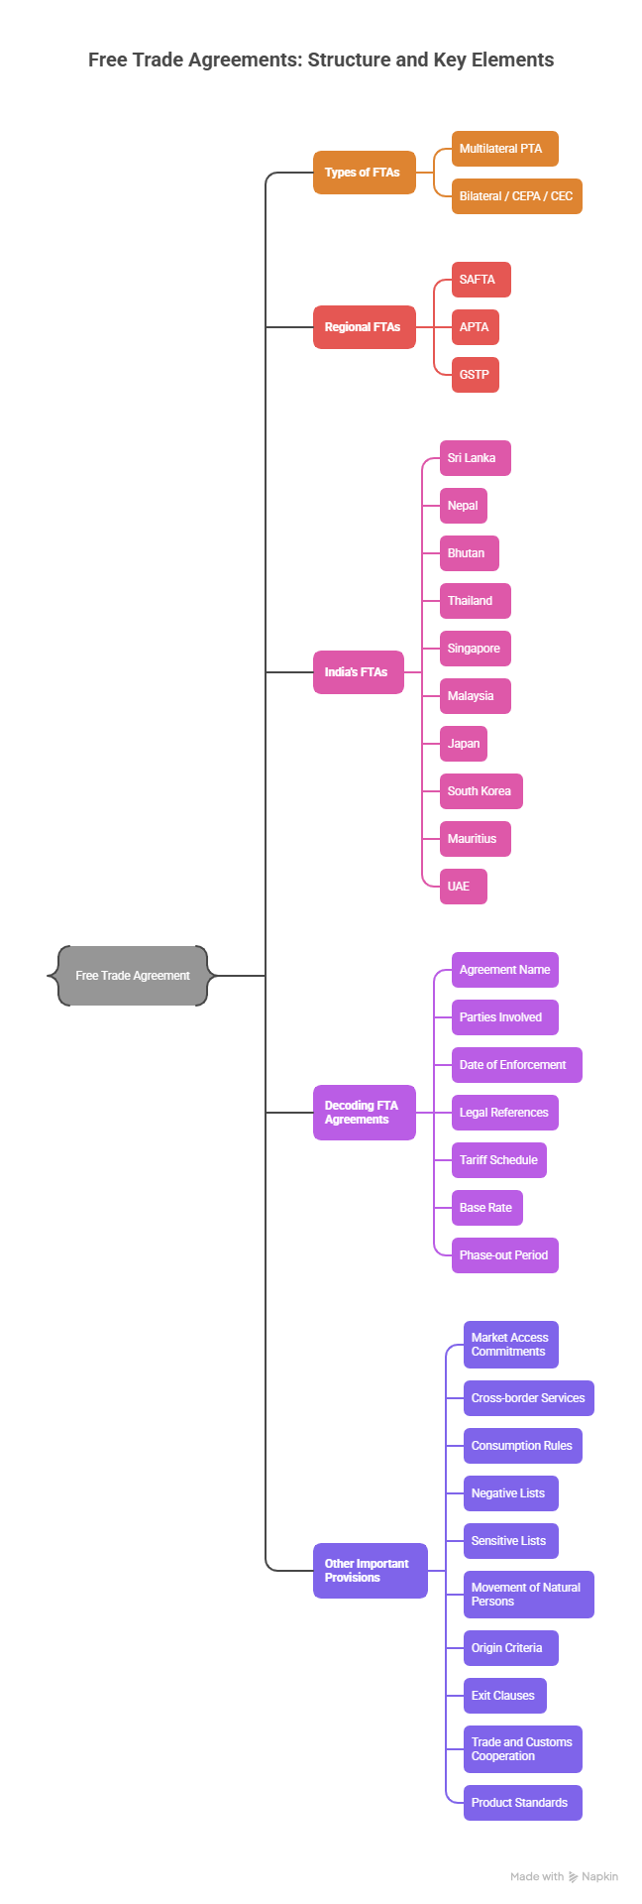Free trade agreements**: FTA:

1. Multilateral regional agreements and
2. Bilateral partnerships with countries across Asia, the Middle East, Africa, and Europe.

These FTAs serve to reduce tariffs, promote trade flows in goods and services, and often include provisions on investment, mobility, intellectual property etc.

**Multilateral & Preferential Trade Agreements (In Force)**

* South Asian Free Trade Area (SAFTA) – Among SAARC nations: Afghanistan, Bangladesh, Bhutan, India, Maldives, Nepal, Pakistan, Sri Lanka.
* Asia-Pacific Trade Agreement (APTA) – Includes Bangladesh, China, South Korea, Sri Lanka, and others.
* Global System of Trade Preferences (GSTP) – A multilateral preferential regime involving 42 countries, including India.

**Bilateral FTAs / CEPAs / CECAs (In Force)**

FTAs between India and other countries/regions:

* India–Sri Lanka FTA – Bilateral FTA with Sri Lanka  .
* India–Nepal Treaty of Trade – Preferential access between India and Nepal  .
* India–Bhutan Trade, Commerce & Transit Agreement – Bilateral pact eliminating trade barriers  .
* India–Thailand FTA (Early Harvest Scheme) – Partial early-harvest arrangement with Thailand  .
* India–Singapore CECA – Comprehensive Economic Cooperation Agreement signed in 2005  .
* India–Malaysia CECA – Comprehensive Economic Cooperation Agreement operational since 2011  .
* India–Japan CEPA – Economic Partnership Agreement in effect since 2011  .
* India–South Korea CEPA – Agreement effective since January 1, 2010  .
* India–Mauritius CECPA – Signed in February 2021; first FTA with an African country  .
* India–UAE CEPA – Signed in February 2022; came into force in May 2022  .
* India–Australia Economic Cooperation & Trade Agreement (ECTA) – Interim agreement signed in April 2022  .
* India–EFTA TEPA – Trade and Economic Partnership Agreement with EFTA (Iceland, Switzerland, Norway, Liechtenstein); signed March 2024, expected to be effective by late 2025  .

**Summary Table: India’s Active FTAs**

|  |  |
| --- | --- |
| **Type** | **Agreement / Region / Country** |
| Multilateral / Preferential | SAFTA (SAARC), APTA, GSTP |
| Bilateral / Regional FTAs | Sri Lanka, Nepal, Bhutan, Thailand (EHS), Singapore, Malaysia, Japan, South Korea, Mauritius, UAE, Australia (ECTA), EFTA |

Here’s the 5 Ws and 1 H framework for Free Trade Agreements (FTAs), (in the context of India) AND LEGAL References:

**1. Why (Purpose / Objective)**

* To boost trade and economic growth by reducing or eliminating tariffs, quotas, and other barriers.
* To access new markets for Indian goods & services.
* To secure raw materials and essential imports at competitive rates.
* To attract foreign investment by ensuring predictable trade rules.
* To strengthen diplomatic & strategic ties with partner nations.

Legal basis:

* Constitution of India – Article 246 & 253 → Parliament’s power to legislate on foreign trade.
* Foreign Trade (Development and Regulation) Act, 1992 (FTDR Act) → Empowers Central Government to make provisions for the development and regulation of foreign trade.
* Customs Act, 1962 → Provides for exemptions/reductions in duties under FTAs through Customs Notifications.
* WTO Agreements → Especially GATT Article XXIV, allowing regional trade agreements.

**2. When (Timing / Context)**

* FTAs are signed after feasibility studies, negotiations, and consultations with stakeholders (industry, government, trade bodies).
* Often pursued when:
  + Trade potential with a country is high but underutilized.
  + Competitor countries have better access due to their own FTAs.
  + Global or regional trade shifts make diversification necessary.
* Example: India signed the India–UAE CEPA in 2022 to quickly expand bilateral trade after pandemic disruptions.

Legal reference:

* Section 5, FTDR Act, 1992 → Government may formulate and amend the Foreign Trade Policy (FTP) to implement FTAs.
* Foreign Trade Policy (FTP) 2023 → Chapter 2 & 9 specify the framework for preferential tariff benefits and implementation timelines.

**3. Who (Stakeholders / Signatories)**

* Government of India – usually led by the Ministry of Commerce & Industry, specifically the Department of Commerce.
* Partner country’s government – relevant ministry or trade department.
* Trade negotiators, diplomats, and legal experts from both sides.
* Industry associations (e.g., FIEO, CII, FICCI) who provide inputs.
* Exporters & importers who directly benefit from the agreement.

Legal reference:

* Allocation of Business Rules, 1961 → Ministry of Commerce & Industry (Department of Commerce) handles FTA negotiations.
* Cabinet Committee on Economic Affairs (CCEA) approval is mandatory before signing.
* Ministry of Law & Justice vets the legal text before signing.

**4. Where (Venue / Scope)**

* Negotiations can take place in either country or at neutral international venues (e.g., Geneva, WTO side meetings).
* FTAs apply to:
  + Goods trade (industrial, agricultural products).
  + Services trade (IT, tourism, finance, education, etc.).
  + Investment & intellectual property provisions in comprehensive deals.

Legal reference:

* FTDR Act, 1992 & Customs Tariff Act, 1975 → Enable preferential tariff rates at Indian customs points for FTA partner countries.
* DGFT Notifications / Public Notices → Notify operational guidelines for exporters/importers.
* Customs (Administration of Rules of Origin under Trade Agreements) Rules, 2020 (CAROTAR 2020) → Lay down the procedural framework for verifying origin claims under FTAs

**5. What (Definition / Nature)**

* A Free Trade Agreement is a pact between two or more countries to reduce or remove trade barriers for goods and/or services.
* Types in India’s context:
  + Bilateral FTAs – between two countries (e.g., India–Japan CEPA).
  + Multilateral/Regional FTAs – between multiple countries (e.g., SAFTA).
  + Comprehensive Agreements – covering trade in goods, services, investments (e.g., CEPA, CECA, ECTA).

Legal reference:

* While “FTA” is not explicitly defined in a single Indian statute, it is recognised under:
  + WTO Law (Marrakesh Agreement, 1994).
  + Bilateral & Multilateral Treaty Law (Vienna Convention on the Law of Treaties, 1969 — India is not a signatory but follows its principles).
  + DGFT Policy Circulars explaining scope of goods & services coverage.

**6. How (Process / Execution)**

1. Feasibility Study – to assess economic gains, risks, and sectoral impacts.
2. Negotiation – tariff schedules, rules of origin, service commitments, dispute resolution.
3. Draft Agreement – legal text prepared by both sides.
4. Approval & Ratification – by the respective governments.
5. Implementation – customs procedures updated, exporters informed.
6. Monitoring & Review – track trade performance, update terms if needed.

Legal reference:

1. Negotiation & Signing – No separate legislation; governed by executive power under Article 73 of the Constitution.

2. Cabinet Approval – As per Transaction of Business Rules, 1961.

3. Customs Notification – Issued under Section 25 of the Customs Act, 1962 to give tariff concessions.

4. DGFT Notification / Public Notice – Issued under Section 5 of FTDR Act, 1992 to operationalise the FTA in trade policy.

5. Origin Verification – As per CAROTAR, 2020 read with specific FTA’s Rules of Origin.